Git commands

>git config --global user.name "neeraj"

>git config --global user.email "neerajkapoor316@gmail.com"

>d:

cd "Software Testing"

cd gitstuff

>git init

git add \*

git commit -m "first comment"

git remote add origin https://github.com/neerajkapoor316/GitDemo.git

git push origin master

https://github.com/neerajkapoor316/GitDemo/tree/master/Chavvi

username-neerajkapoor316

passwrd-

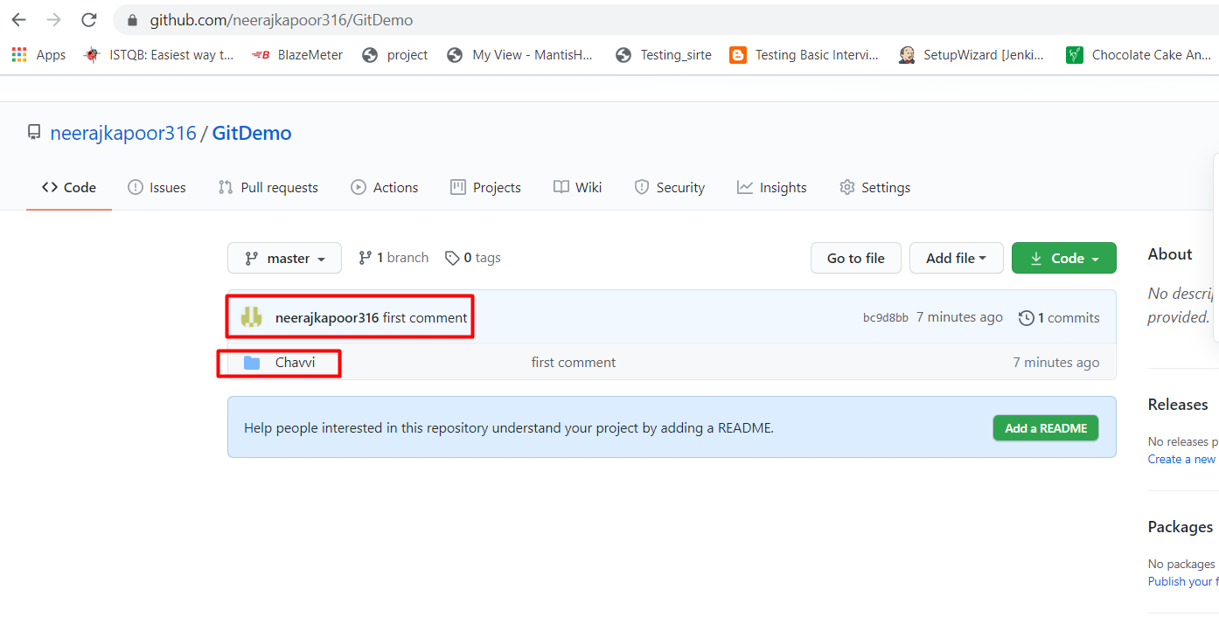

Pull the Project from git to computer

git clone https://github.com/neerajkapoor316/GitDemo.git